**Mid-Term**

Date: July 17, 2017 Name: Anukul Raj

1. Study of human physical capabilities, cognition and physiology leads to a better understanding of human (brain and body) interaction with the system. This will result in obtaining maximum output, safer environment and a healthy human that correlates directly to Human Factors Goals. It also helps in early detection of problems and solutions implementation for better design of equipment, task, environment, selection and training programs. Hence, minimizing the accidents.
2. The system operator, Bill could have prioritized his work by calling for an in-city generation at right time, shedding of the power or call up his boss instead of delaying. In the tumult, the brain and body coordination does not coordinate, like even after following the instructions by his boss, he turned the selector switch onto the wrong side. Human Factors identifies the problem and modifies the design to give a safe and better interaction with the system. In a crisis, the physical equipment must be so designed with clear push buttons, the system design has to be automated as this might reduce the mental work pressure. Also, manual operations should be enabled if and when necessary to make the operator-system interactions more flexible. An emergency voice note would have guided Bill to call the required personnel for guided help or it might have prompted him to shed the load. Training has to be provided to the operator for all sorts of situations. Sometimes, handling emergency individually is a vital aspect. Although Bill is experienced, he preferred to rely on Kennedy and others for instructions in the time of need. The selection process for the operator has to include tests for emergency as this might help to get the best employee at work. If the Con Edison system incorporated these changes prior to the act of God, it would have saved 25 hours of an outage caused due to mishandling of the situation roughly over an hour of time.
3. A) This should be considered as applied research, as the research is being done with respect to a product instead just to gain more knowledge about the application.

B) In my opinion a within subject design would be best suited here, as we can have the same subject participate in both the condition. The first condition could be measuring the person’s water intake and exercise habits without the application and then, measuring the same subject’s water intake and exercise regime with the app in combination with the smart watch. The advantages of using this type of experimental design comparatively do not require a large pool of participants. In addition, since all the individuals are subjected to all conditions, so the result will not be distorted by individual differences. The disadvantage of using this type of experimentation can be participants dropping out the mind of the experiment, a generalization of result applies only to the individual and not to the population in general. The variables to be considered here are:

* + Age
  + Sex

C) She should report the mean increase or decrease in the water intake and exercise improvement after being subjected to treatment, for the inferential statistics, she should report a two-sample t-test.

1. The working memory is a part of a cognitive system that temporarily holds the information that for the processing. Verbal and spatial information are stored. The capacity to store information is 7(+-)2 chucks and its vulnerable to confusion and improper attention. The long-term memory refers to the part of the cognitive system where information can be stored for longer periods. Facts and events memory are stored here. Employers can arrange to provide all non-essential information hence removing the need for the employee to remember much. For Ex: Providing the extension of most of the employees through operators.
2. While reading book first bottoms up processing comes into the picture as we start processing the information through our sensory organs. Then we start understanding the meaning of the sentences even if there are some words, being unfamiliar, with the help of top down approach. While watching a visual display again, we perceive information through bottoms up approach. After a while, we start making a sense-using top down approach.
3. A) Schema and Scripts: Before applying for a leave at the workplace, thinking that manager would not approve the request based on experience in the previous workplace is a schema. Getting up in the morning and starting the coffee machine is a script.

B) Mental Model: Figuring out the functionality of a new machine such as a printer without looking at manual.

C) Cognitive Map: Guiding someone without using any map over the call.

1. The Skill based behavior refers to the subconscious automated routines. These are those behaviors are imbibed in an individual’s daily life and they act upon it without thinking. Such as any mechanic using the tool, or a Chef cutting vegetables.

The rule-based behaviors refer to those behaviors that have been incorporated in us as rules meaning particular action based on the particular scenario. Like stopping the vehicle at a red light.

The knowledge-based behavior is those behaviors that are improvised. Behavior in unknown circumstances, with no routine or rule to guide. Trying to put new things and figuring things out.

Factors affecting different decision-making processes are:

* Past Experiences
* Cognitive biases
* Individual Differences
* Age
* Socio Economic Status

1. **Anchoring:** This refers to human mind tendency of to hold on the first piece of information and making a decision based on that. Ex: Purchasing an airline ticket after hearing the first information about a ticket price and ignoring other factors like journey duration or a number of layovers.

**Availability Heuristic:** Decision made based on the impact of previous examples stored in mind. It works on the principle that if that example came to mind then that would be important rather than the alternative. Ex: Not deciding to go to a new restaurant because some person fell sick after eating there.

**Satisficing:** This means coming to a decision without weighing alternatives or solutions. Ex: Going to a showroom and buying a particular brand that someone always wanted and not considering another alternative

**Representative Heuristic:** Making a decisionby connecting resemblance with other class of objects or events. Ex: Buying a similar product looking exactly like the one you used before.

**Overconfidence:** Making a decision based on your own thinking and confidence without estimating the real scenario. Ex: Appearing for an examination without any preparation as you have always bested that exam previously.

1. Stress is a reaction that to a situation or event that seems as a threat and requires actions beyond an individual’s normal operational intensity level. Some of the common sources of stress or stressors are:
   * Environmental Stressors -- These type of stressors have clearly defined direct effects and magnitudes are measurable. The stimulus incorporating these are Noise, Lightning, Motion, Temperature or, Air Quality.
   * Psychological Stressors – This category consists of stressors resulting from the perceived threat of harm or loss of esteem (i.e. potential embarrassment), of something valued, or of bodily functions through injury or death. This stress amount to the individual’s own assessment of the situation also known as Cognitive Appraisals, leading to an increase in the physiological arousal.
   * Life Stressors – This type of stress arises from the life of the individual, either his job or, personal life or both. These include stress caused due to poor-management, insecurity of job, issues in a marriage or the death of a loved one.

Stress remediation is very important as stress levels negatively affects a person’s well-being sometimes leading to persistent health problems and negatively affecting the performance of the individual. The following steps help to remediate stress:

* Stress Management Training such as inhibiting the tendency to respond immediately or breathing exercises
* Pre-determined steps in case of an emergency such as design of displays, controls or procedures
* Addressing the real cause of stress
* Talking to a counselor
* Exercises and maintaining healthy lifestyle

1. The graph and calculation are mentioned in the picture below:

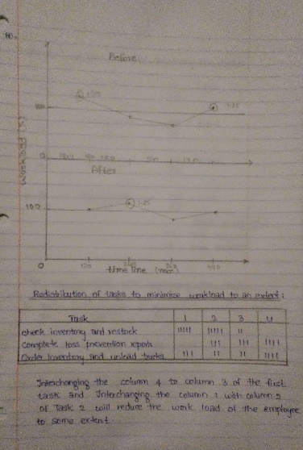 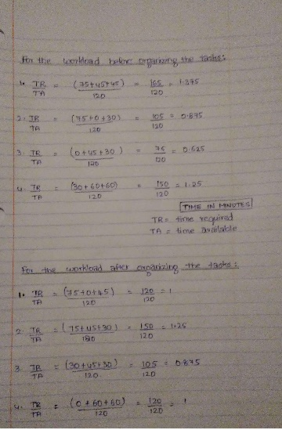

1. The following steps should be by the employers to prevent and alleviate fatigue due to sleep and circadian disruption
   * Controlled napping strategy should be implemented with addition of  
     allowing 10 minutes allowance for full recovery of mental functions
   * Assign workers permanently to different shifts, assuming that the  
     body and mind will eventually adapt (desynchronization)
   * Assigning delayed shifts instead of advanced shifts
   * Emphasizing the importance of adequate sleep and not promoting  
     trends where workers try to work by keeping up more than one day
   * Short term remediation includes availability of free Coffee